Homework 6

Jiaqi Li

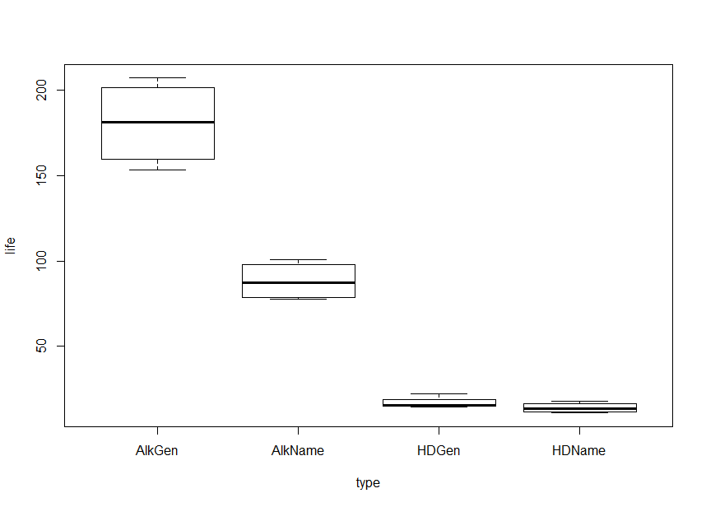**1.**

**2.**

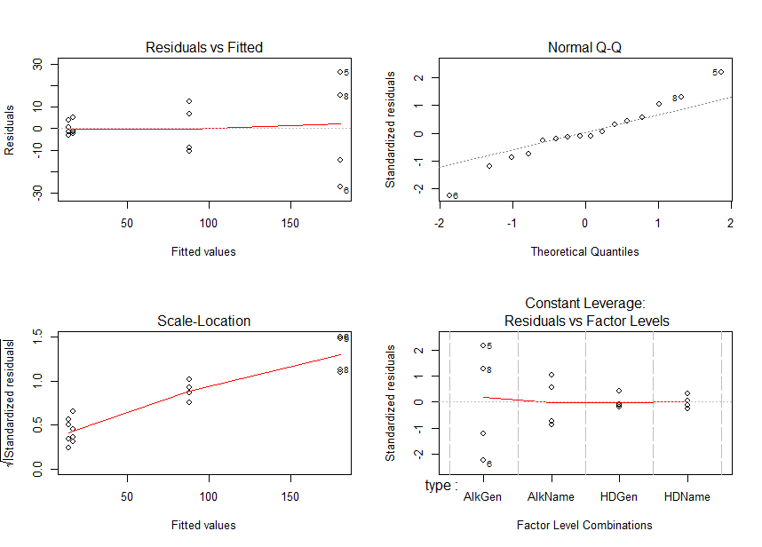

(a)

Yit = μ + τi + ϵit , ϵit ∼ N(0, σ2) with iid.

i = 1, 2, 3, 4

t = 1, 2, 3, 4

(b)

By Q-Q plot, we observe that residuals are not fitting the line well, which indicates that residuals violate normality.

(c)

By the scatter plot, we observe that residuals do not have constant variance since the variance of residuals are getting larger.

Thus, the assumption of constant error variance among treatments is NOT justified.

**3.** 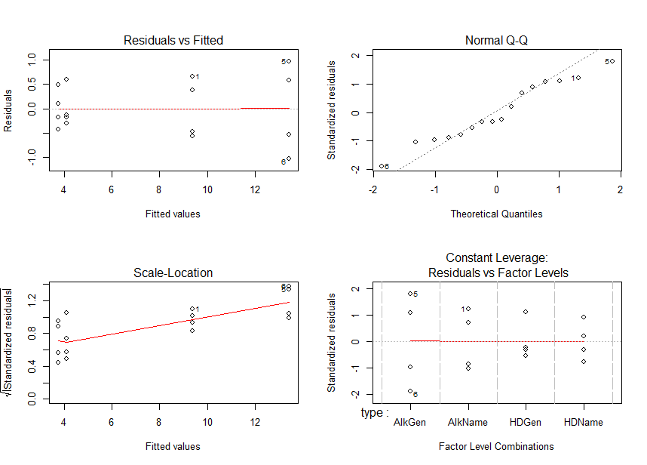

(a)

$\sqrt{Y{}_{it}}$ = μ + τi + ϵit , ϵit ∼ N(0, σ2) with iid.

i = 1, 2, 3, 4

t = 1, 2, 3, 4

(b)

By Q-Q plot, we observe that residuals fit the line well, which indicates that residuals satisfy normality.

(c)

By the scatter plot, we observe that variances of residuals are approximately constant.

Thus, the assumption of constant error variance among treatments is justified.

**4.**

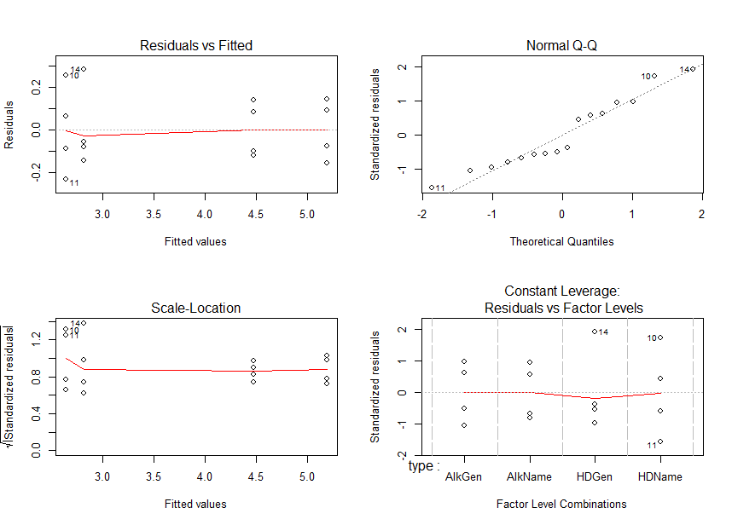

(a)

$\log{Y_{it}}$ = μ + τi + ϵit , ϵit ∼ N(0, σ2) with iid.

i = 1, 2, 3, 4

t = 1, 2, 3, 4

(b)

By Q-Q plot, we observe that residuals fit the line well, which indicates that residuals satisfy normality.

(c)

By the scatter plot, we observe that variances of residuals are approximately constant.

Thus, the assumption of constant error variance among treatments is justified.

**5.**

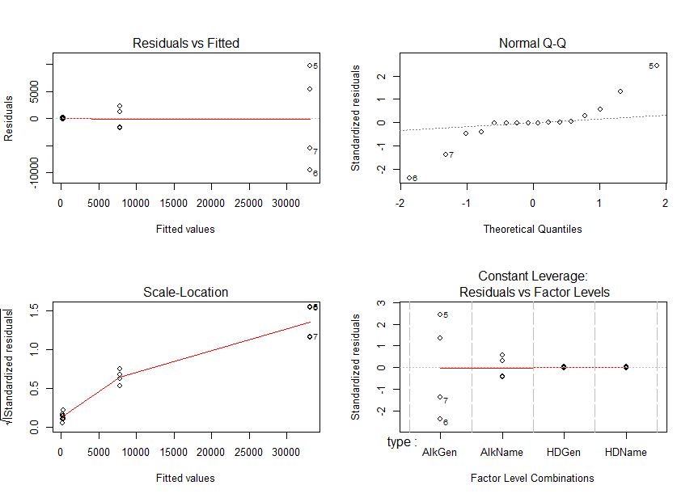

(a)

Yit2 = μ + τi + ϵit , ϵit ∼ N(0, σ2) with iid.

i = 1, 2, 3, 4

ti = 1, 2, 3, 4

(b)

By Q-Q plot, we observe that residuals are not fitting the line well, which indicates that residuals violate normality.

(c)

By the scatter plot, we observe that residuals do not have constant variance since the variance of residuals are getting larger.

Thus, the assumption of constant error variance among treatments is NOT justified.

**6.**

Square-root of the battery life and log of the battery life satisfy the assumptions of ANOVA model.

Also, by observing the scatter plot, we see that residuals of log of the battery life have smaller variance.

Thus, the model with the log of the battery life as a response variable best satisfy the assumptions of ANOVA model.

**7.**

> summary(fit3)

Df Sum Sq Mean Sq F value Pr(>F)

type 3 18.80 6.267 215.2 1.08e-10 ***

Residuals 12 0.35 0.029

---

Signif. codes: 0 ‘***’ 0.001 ‘**’ 0.01 ‘*’ 0.05 ‘.’ 0.1 ‘ ’ 1

H0: τ1=τ2=τ3=τ4

H1: At least one of τi is different with others.

T* = F3,12 = 215.2

p-value = 1.08 × 10-10 < α = 0.05

Thus, reject null hypothesis and conclude that there is enough evidence to show that at least one of τi is different with others for i=1,2,3,4.

> lsm.life=lsmeans(fit3, ~type)

> kable(summary(contrast(lsm.life,method="pairwise",adjust="tukey"),infer=c(T,T),level=0.5,side="two-sided"))

|contrast | estimate| SE| df| lower.CL| upper.CL| t.ratio| p.value|

|:----------------|---------:|---------:|--:|----------:|---------:|---------:|---------:|

|AlkGen - AlkName | 0.7157653| 0.1206763| 12| 0.5419570| 0.8895736| 5.931281| 0.0003481|

|AlkGen - HDGen | 2.3758523| 0.1206763| 12| 2.2020440| 2.5496606| 19.687807| 0.0000000|

|AlkGen - HDName | 2.5489199| 0.1206763| 12| 2.3751116| 2.7227281| 21.121954| 0.0000000|

|AlkName - HDGen | 1.6600870| 0.1206763| 12| 1.4862788| 1.8338953| 13.756526| 0.0000001|

|AlkName - HDName | 1.8331546| 0.1206763| 12| 1.6593463| 2.0069629| 15.190672| 0.0000000|

|HDGen - HDName | 0.1730675| 0.1206763| 12| -0.0007407| 0.3468758| 1.434147| 0.5034253|

From the table above, we see that only the p-value of contrast between HDGen and HDName is larger than α=0.05.

Thus, all contrasts have significant pairwise differences in mean lifetime of different battery types except the contrast between HDGen and HDName.

**8.**

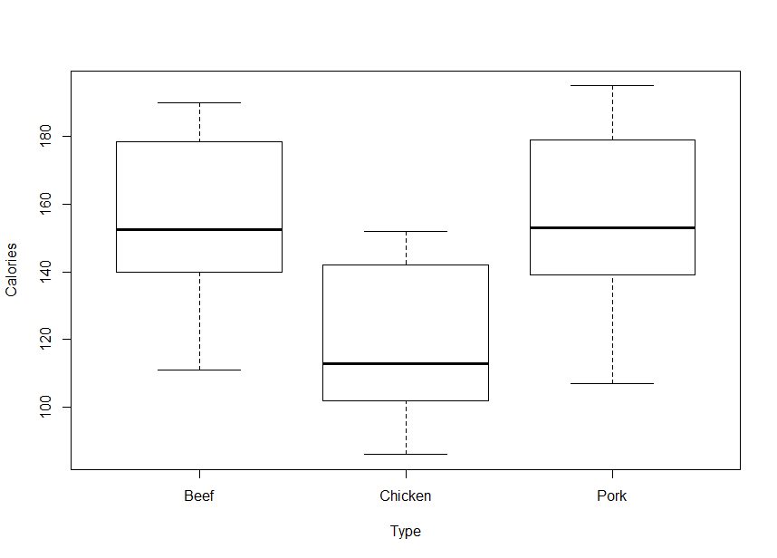

First, we try this model:

Yit = μ + τi + ϵit , ϵit ∼ N(0, σ2) with iid.

Response is simply the Calories

i = 1, 2, 3

t = 1, …, ri where r1 = 20, r2 = 17, r3 = 17

Then, we look at the residual plots:

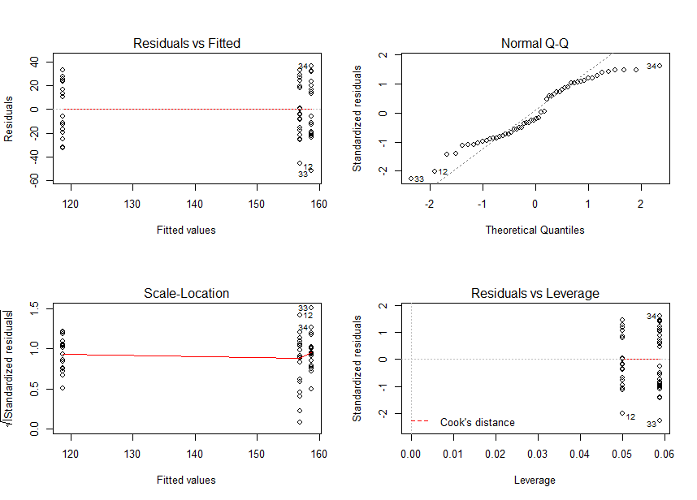

From the Q-Q plot, we can observe that residuals do not fit the line well at the right upper corner, which indicates that residuals in this model may violate the normality assumption.

Thus, we use transformations and try other 5 models and finally select the following model (coded as m5 in R):

1/Yit = μ + τi + ϵit , ϵit ∼ N(0, σ2) with iid.

Response is the Inverse of Calories

i = 1, 2, 3

t = 1, …, ri where r1 = 20, r2 = 17, r3 = 17

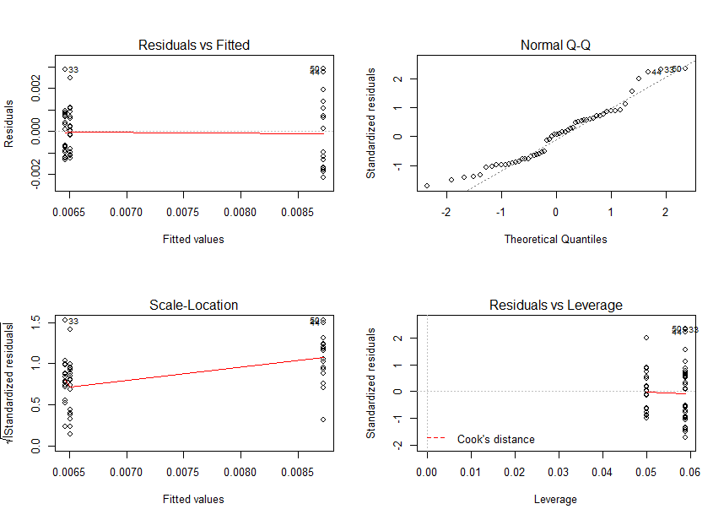

By Q-Q plot, we observe that residuals fit the line well, which indicates that residuals satisfy normality.

By the scatter plot, we observe that variances of residuals are approximately constant.

By the scatter plot, we can observe a linear trend among residuals, which satisfies the linearity.

Thus, assumptions of ANOVA model are all justified. Then, we can analyze data by using this model.

> summary(m5)

Df Sum Sq Mean Sq F value Pr(>F)

Type 2 5.805e-05 2.903e-05 17.61 1.53e-06 ***

Residuals 51 8.406e-05 1.648e-06

---

Signif. codes: 0 ‘***’ 0.001 ‘**’ 0.01 ‘*’ 0.05 ‘.’ 0.1 ‘ ’ 1

H0: τ1=τ2=τ3

H1: At least one of τi is different with others.

T* = F2,51 = 17.61

p-value = 1.53 × 10-6 < α = 0.05

Thus, reject null hypothesis and conclude that there is enough evidence to show that at least one of τi is different with others for i=1,2,3.

> lsm.hotdog=lsmeans(m5, ~Type)

> kable(summary(contrast(lsm.hotdog,method="pairwise",adjust="tukey"),infer=c(T,T),level=0.5,side="two-sided"))

|contrast | estimate| SE| df| lower.CL| upper.CL| t.ratio| p.value|

|:--------------|----------:|---------:|--:|----------:|----------:|----------:|---------:|

|Beef - Chicken | -0.0022119| 0.0004235| 51| -0.0026907| -0.0017331| -5.2226554| 0.0000097|

|Beef - Pork | 0.0000438| 0.0004235| 51| -0.0004350| 0.0005226| 0.1034495| 0.9941180|

|Chicken - Pork | 0.0022557| 0.0004404| 51| 0.0017579| 0.0027535| 5.1224837| 0.0000138|

From the table above, we see that only the p-value of contrast between Beef and Pork is larger than α=0.05.

Beef hotdog has larger mean hotdog calories than Chicken hotdog.

Pork hotdog has larger mean hotdog calories than Chicken hotdog.

Contrast between Beef and Pork does NOT have significant pairwise differences in mean hotdog calories of different meat types

No other significant pairwise differences in mean hotdog calories of different meat types.

**R code:**

type<-c("AlkName","AlkName","AlkName","AlkName","AlkGen","AlkGen","AlkGen","AlkGen","HDName","HDName","HDName","HDName","HDGen","HDGen","HDGen","HDGen")

life<-c(100.668,77.734,79.210,95.063,206.880,153.347,165.980,196.000,14.951,18.063,11.111,12.840,15.340,22.090,15.734,14.440)

batt<-data.frame(type=type, life=life)

plot(batt)

fit1<-aov(life~type,data=batt)

par(mfrow=c(2,2))

plot(fit1)

batt$SqrtLife<-sqrt(life)

batt$LogLife<-log(life)

batt$SqLife<-life*life

fit2<-aov(SqrtLife~type,data = batt)

par(mfrow=c(2,2))

plot(fit2)

fit3<-aov(LogLife~type,data = batt)

par(mfrow=c(2,2))

plot(fit3)

fit4<-aov(SqLife~type, data = batt)

par(mfrow=c(2,2))

plot(fit4)

summary(fit3)

install.packages("knitr")

library(knitr)

install.packages("lsmeans")

library(lsmeans)

lsm.life=lsmeans(fit3, ~type)

kable(summary(contrast(lsm.life,method="pairwise",adjust="tukey"),infer=c(T,T),level=0.5,side="two-sided"))

#8---------------------------------------------------------------------------------------------------------------

hotdog=read.table("hotdogs.txt",header=TRUE)

hotdog

attach(hotdog)

plot(Calories~Type)

m1<-aov(Calories~Type,data=batt)

par(mfrow=c(2,2))

plot(m1)

hotdog$SqrtC<-sqrt(Calories)

hotdog$LogC<-log(Calories)

hotdog$SqC<-Calories*Calories

hotdog$InvC<-1/Calories

hotdog$TrirtC<-Calories^(1/3)

m2<-aov(SqrtC~Type,data =hotdog)

par(mfrow=c(2,2))

plot(m2)

m3<-aov(LogC~Type,data = hotdog)

par(mfrow=c(2,2))

plot(m3)

m4<-aov(SqC~Type, data = hotdog)

par(mfrow=c(2,2))

plot(m4)

m5<-aov(InvC~Type, data = hotdog)

par(mfrow=c(2,2))

plot(m5)

m6<-aov(TrirtC~Type, data = hotdog)

par(mfrow=c(2,2))

plot(m6)

summary(m5)

lsm.hotdog=lsmeans(m5, ~Type)

kable(summary(contrast(lsm.hotdog,method="pairwise",adjust="tukey"),infer=c(T,T),level=0.5,side="two-sided"))